Developed by Bioing. Johanna Casado on her PhD tesis framework, under direction of Dr. Beatriz García. With general collaboration of Dr. Wanda Diaz Merced, and the collaboration on software development of Bioing. Aldana Palma, Bioing. Julieta Carricondo Robino and Mg. Ing. Gonzalo A. de la Vega.

INSTALATION MANUAL

SonoUno: Sonification Software for astronomical data files presented in table format.

SonoUno team.

sonounoteam@gmail.com

Bioing. Johanna Casado

johanna.casado@iteda.cnea.gov.ar

Index

1. Software description **2**

2. Software installation **2**

2.1. Ubuntu 2

2.1.1. Octave installation 2

2.1.2. Python installation 4

2.1.3. Previous packages needed for Ubuntu 7

2.1.4. SonoUno installation 7

2.1.4.1. Installation with pip 7

2.1.4.1. Installation from the source 9

2.1.1.2. Possible errors 14

2.1.1.3. Run the software 14

2.2. CentOs 16

2.2.1. Installation from the source 16

3. Import a file to the software **16**

# 1. Software description

SonoUno is a sonification software for two column tables of astronomical data. The software is being developed based on the study of other software (Sonification Sandbox, MathTrax and xSonify) and standards of accessibility like the ISO 9241-171:2008 (Guidance on software accessibility). In order to develop the first approach of graphical user interface, we perform a theoretical framework based on bibliography of user cases, focused on blind and visual impairment people.

The develop language is Python and we use modular design, in order to do collaborative work. The sonoUno now is multiplatform, tested on windows 10, Ubuntu 16.04 and Mac High Sierra; the development team work continuously to maintain this benefit. The principal goal of the SonoUno is to allow the user to open data files (txt or csv extension), reproduce the plot and sonification of the data. At the moment, the sonification is perform by variation of pitch in different instruments.

Additionally, SonoUno allow to select a specific range of data on the ‘x’ axis, mark and save point of interest in the data, apply predefined mathematical functions (for example, logarithm and square) and manipulate the data arrays with an Octave interface. In the section settings, the user can configure the plot and change between several predefined instruments (acoustic piano, clavinet, celesta and tubular bells, between others). We expect to include more sound configurations shortly.

Finally, the software allows the user to save the sound, the plot, a text file with the points marked on the data and a csv file with the plotted data.

# 2. Software installation

## 2.1. Ubuntu

### 2.1.1. Octave installation

The next steps describe the octave installation from terminal.

1. First, run the update command (Image 1 and Image 2):
   1. sudo apt update

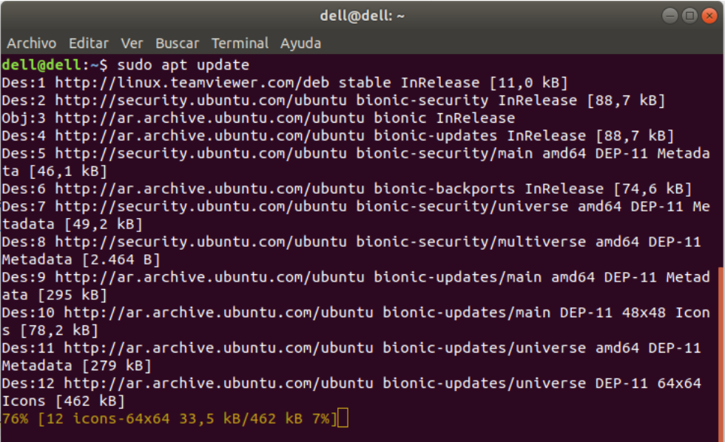

*Image 1 – Shows the result of previous command.*

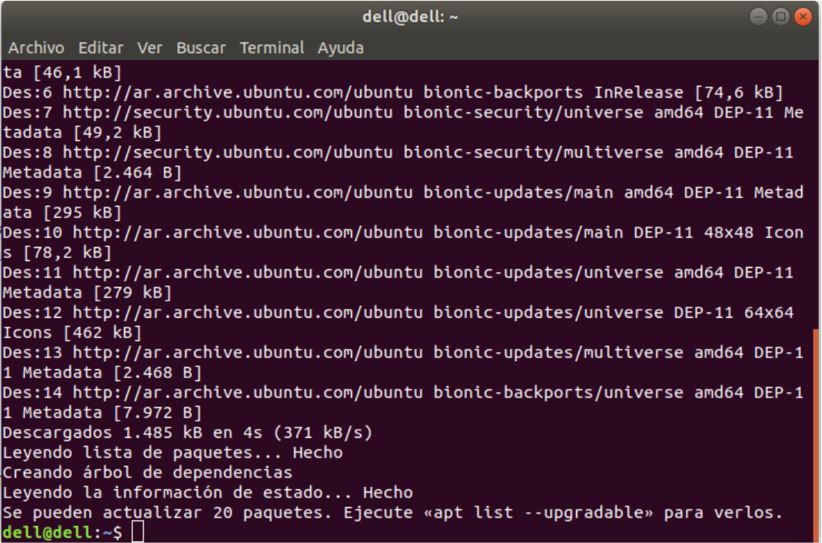

*Image 2 - Shown the last part of the sudo apt update command.*

1. Now we can run the next command to install octave (Image 3, Image 4 and Image 5):
   1. sudo apt install octave

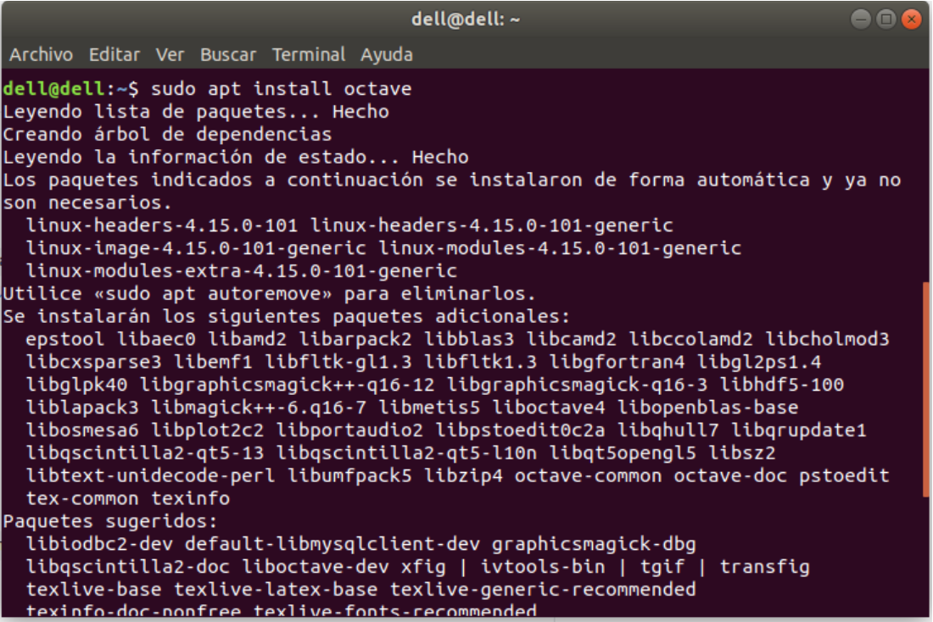

*Image 3 - Shown the first part of the octave installation.*

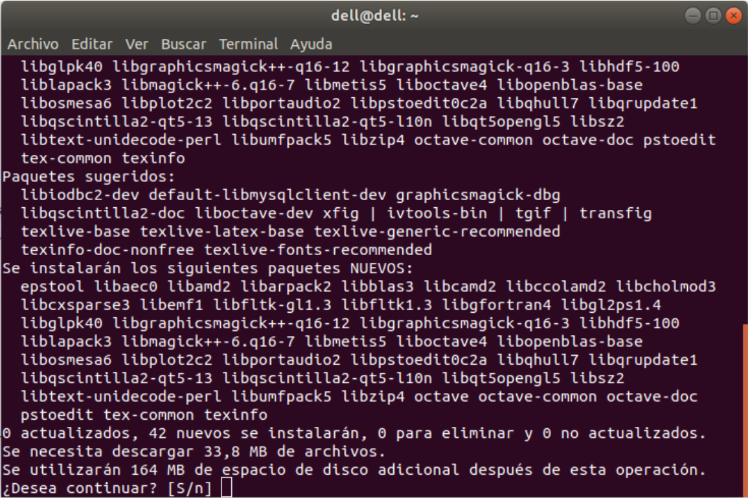

*Image 4 - Shown the part when the octave installation ask if the user want to continue, after shown all the packages to install.*

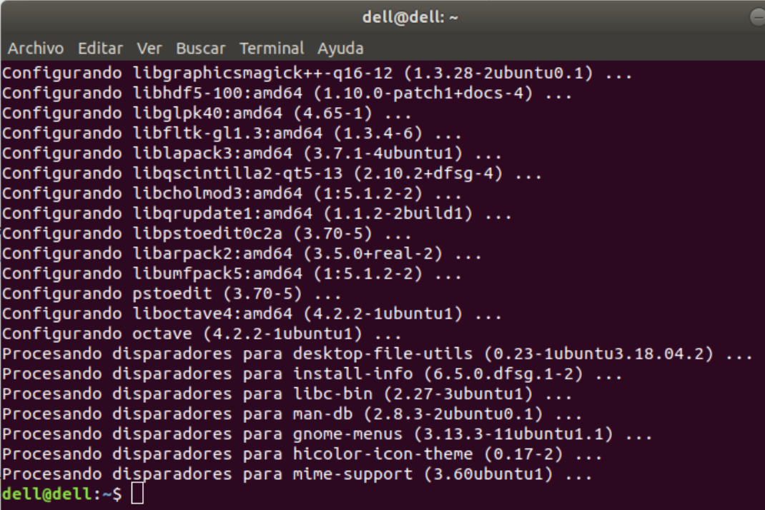

*Image 5 - Shown the last part of the octave installation.*

### 2.1.2. Python installation

If you installed previously the soft with python 3 at your computer, do not take into account this section. If not, the next steps contain the python installation.

1. Go to the terminal and execute ‘python’ command:

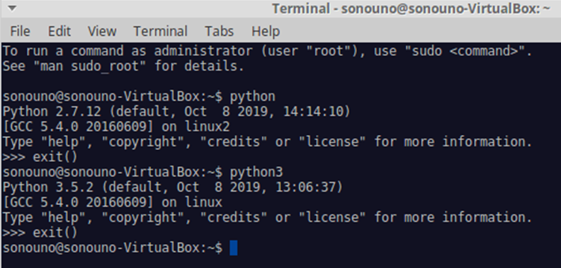

*Image 6 - Checking the installed version of Python in your computer.*

1. If the version is 2.x.x, type exit() and check with ‘python3’. If the version here is 3.x.x (see Image 6) we can continue with the following steps, if not, you must install or update python 3 in the operating system using the command:
   1. sudo apt-get install --upgrade python3

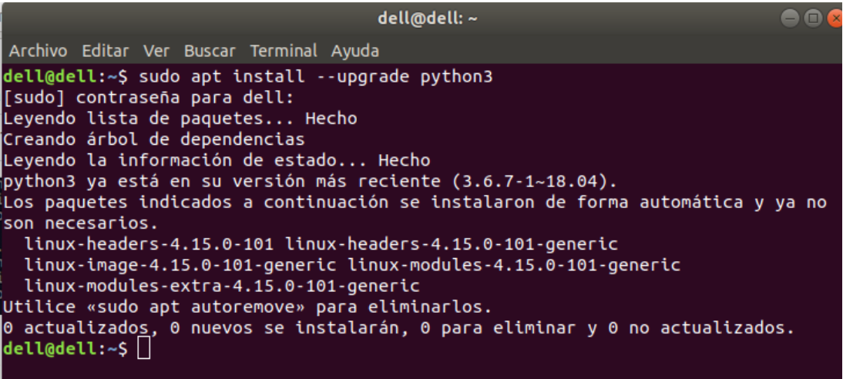

*Image 7 - Shown the result of the command ‘sudo apt-get install --upgrade python3’.*

1. Once that we checked that we have python 3 installed (is called python3 in this instructive), check if you have ‘pip’ installed:
   1. python3 -m pip -V

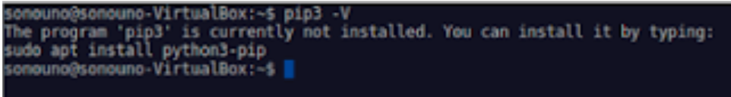

*Image 8 – Shows that pip is not installed, the message begins with ‘The program pip is currently not installed’. This image is illustrative.*

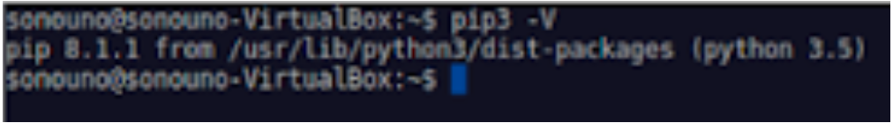

*Image 9 - Shows the version of pip, indicating that pip is installed. This image is illustrative.*

1. If you don’t have ‘pip’ installed (Image 8), execute the next commands (Image 10, Image 11 and Image 12):
   1. sudo apt update

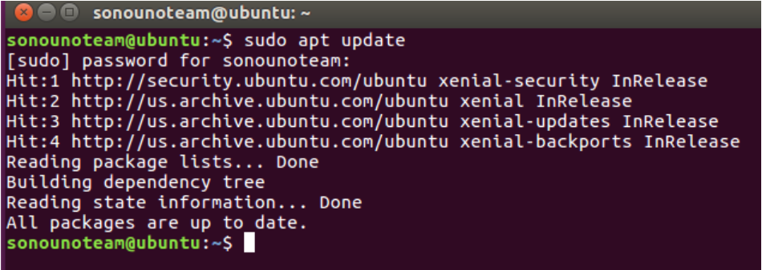

*Image 10 - Implementation of the update command.*

* 1. sudo apt install python3-pip

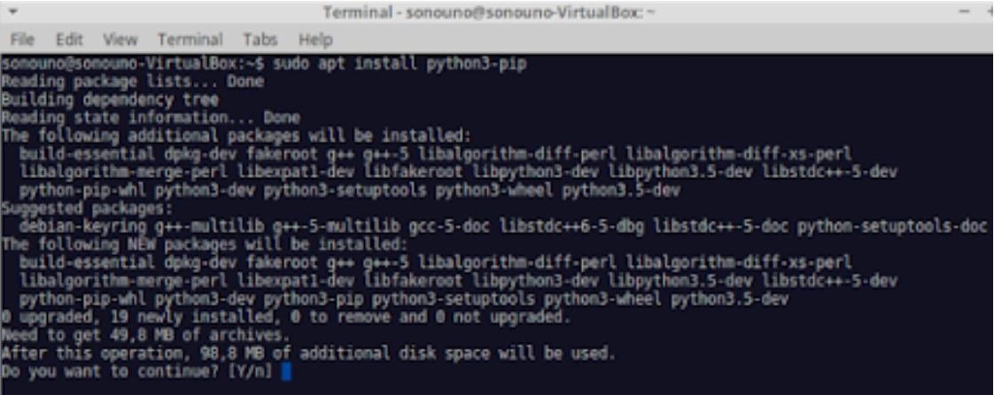

*Image 11 - Shows the pip installation, on the question 'Do you want to continue? you have to type 'Y' and press Enter.*

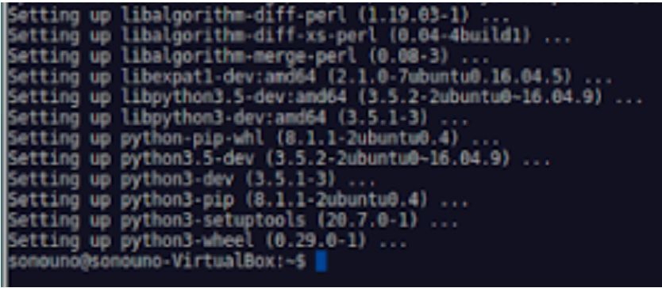

*Image 12 - Shows the final lines of pip installation.*

1. Once we have pip installed (Image 9), we can proceed.

### 2.1.3. Previous packages needed for Ubuntu

Some libraries are required to run the software on Ubuntu, to install them run the next command (Image 13):

* sudo apt install libsdl2-mixer-2.0-0 libsdl2-image-2.0-0 libsdl2-2.0-0 libsdl-ttf2.0-0 libgtk-3-dev

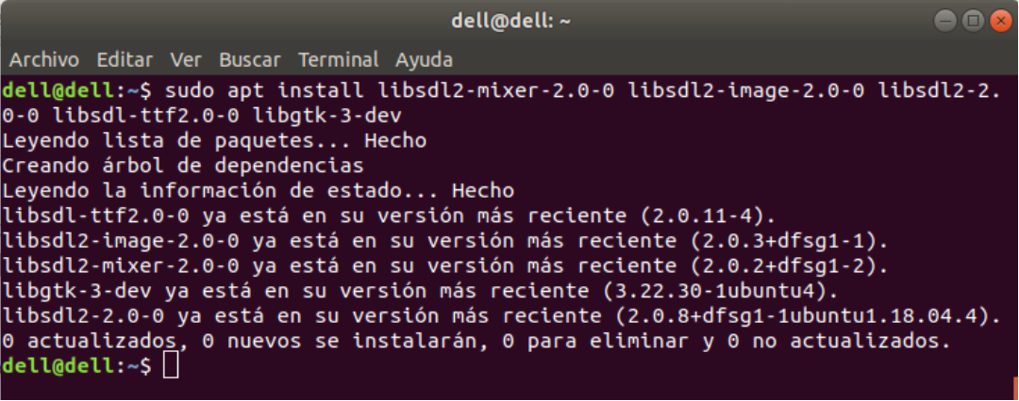

*Image 13 - Shown the result of the libraries installation.*

### 2.1.4. SonoUno installation

#### 2.1.4.1. Installation with pip

First of all, you have to install wxPython with the next command:

* For ubuntu-16.04:
  + python3 -m pip install -U -f https://extras.wxpython.org/wxPython4/extras/linux/gtk3/ubuntu-16.04 wxPython
* For ubuntu-18.04 (Image 14):
  + python3 -m pip install -U -f https://extras.wxpython.org/wxPython4/extras/linux/gtk3/ubuntu-18.04 wxPython
* For ubuntu-20.04:
  + python3 -m pip install -U -f https://extras.wxpython.org/wxPython4/extras/linux/gtk3/ubuntu-20.04 wxPython

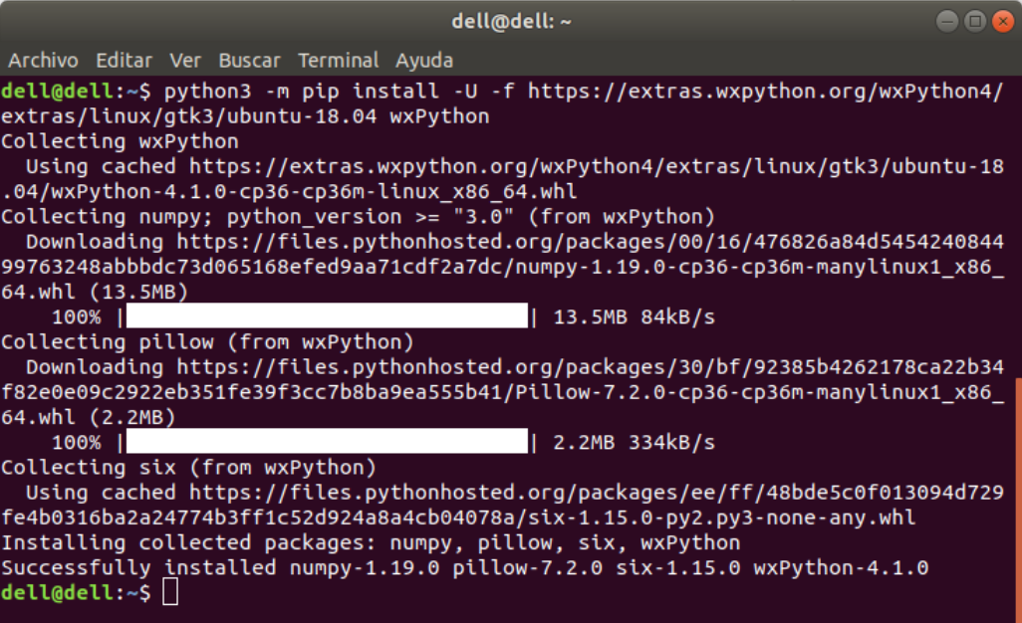

*Image 14 - Installation of wxPython with the previous command.*

If you have a previous version or you are not sure, run the next command to uninstall a possible version:

* sudo python3 -m pip uninstall sonoUno

The previous command can show an error if the program is not installed. To install sonoUno run the next command (Image 15 and Image 16):

* sudo python3 -m pip install sonoUno

**NOTE:** The command update is not recommended because produce a problem trying to install wxPython from pip and in some cases do not allow to install the sonoUno program with pip.

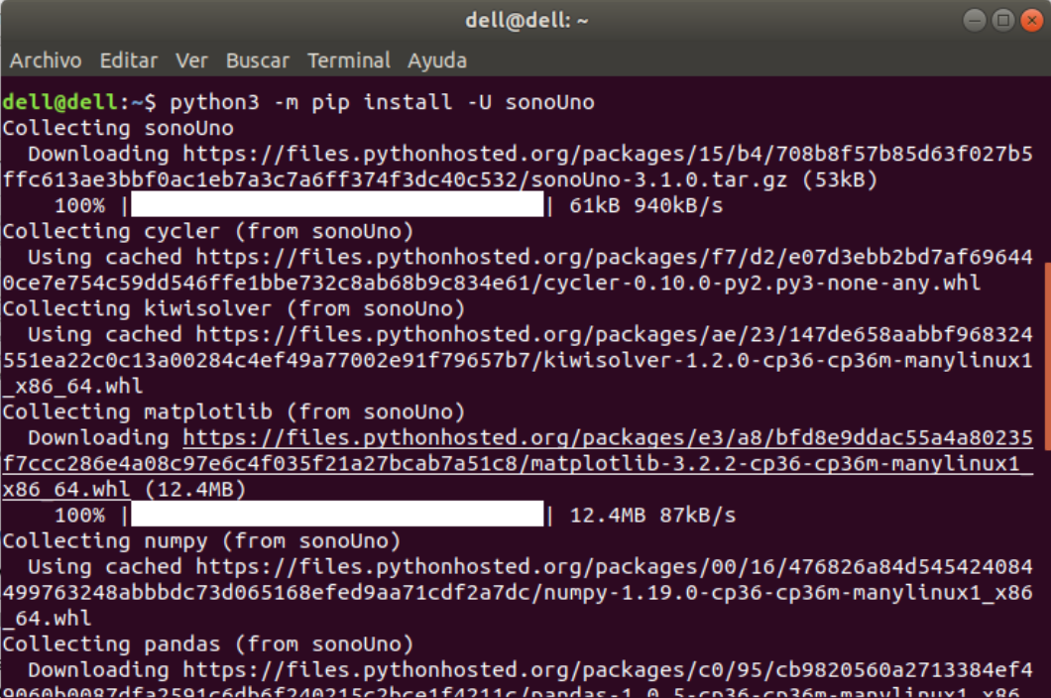

*Image 15 - Shown the first part of the sonoUno installation.*

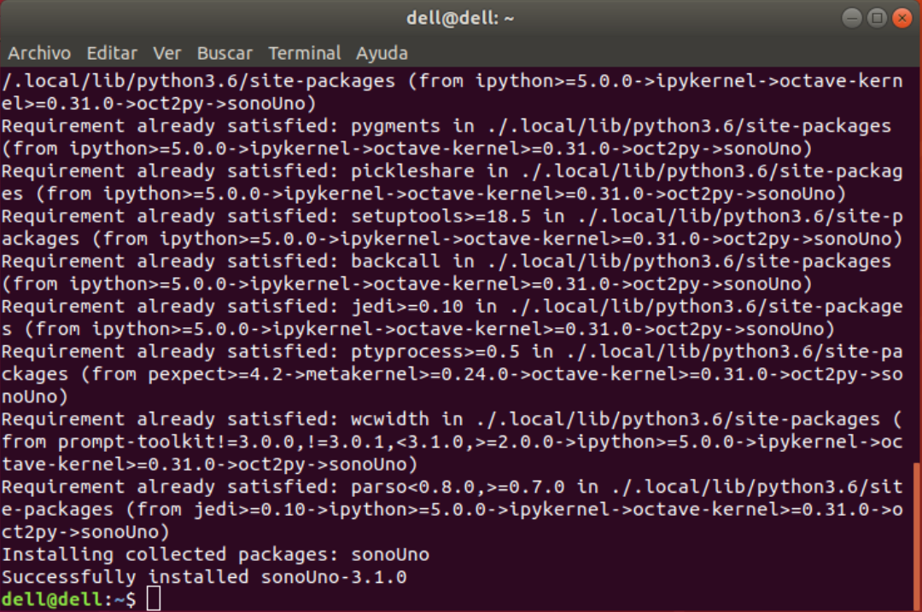

*Image 16 - Shown the last part of the sonoUno installation.*

Finally, to run the sonoUno software write the next command on the terminal (Image 17):

* sonoUno

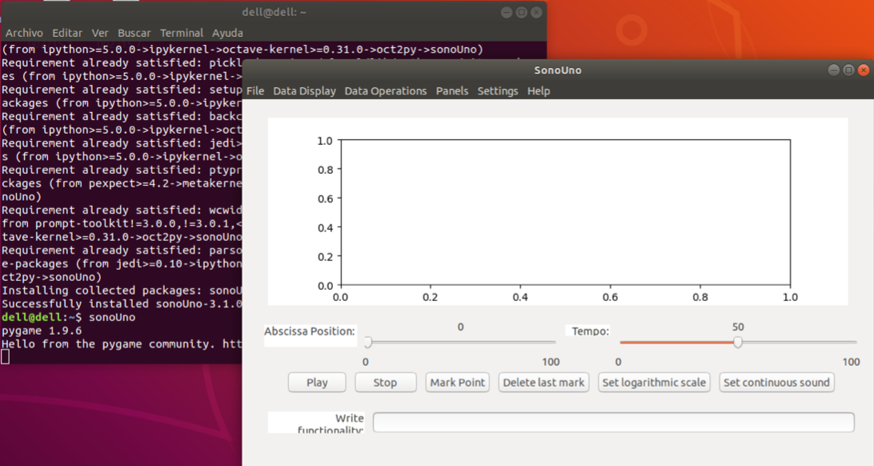

*Image 17 - Shown the sonoUno display opened with the command ‘sonoUno’ after its installation with pip.*

#### 2.1.4.1. Installation from the source

Here we explain how to install each one of the libraries to run sonoUno from source.

1. First you have to type (Image 1):
   1. sudo apt update
2. Install wxPython with the next command (Image 18):

**NOTE:** The installation can take several minutes, be patient. If the installation takes more than 30 minutes cancel the process (Ctrl+C) and execute the command once again. The aspect of the installation, can be seeing in Image 18.

* 1. For ubuntu 20.04
     1. python3 -m pip install -U -f https://extras.wxpython.org/wxPython4/extras/linux/gtk3/ubuntu-20.04 wxPython
  2. For ubuntu 18.04
     1. python3 -m pip install --user -U -f https://extras.wxpython.org/wxPython4/extras/linux/gtk3/ubuntu-18.04 wxPython
  3. For ubuntu 16.04
     1. python3 -m pip install --user -U -f https://extras.wxpython.org/wxPython4/extras/linux/gtk3/ubuntu-16.04 wxPython

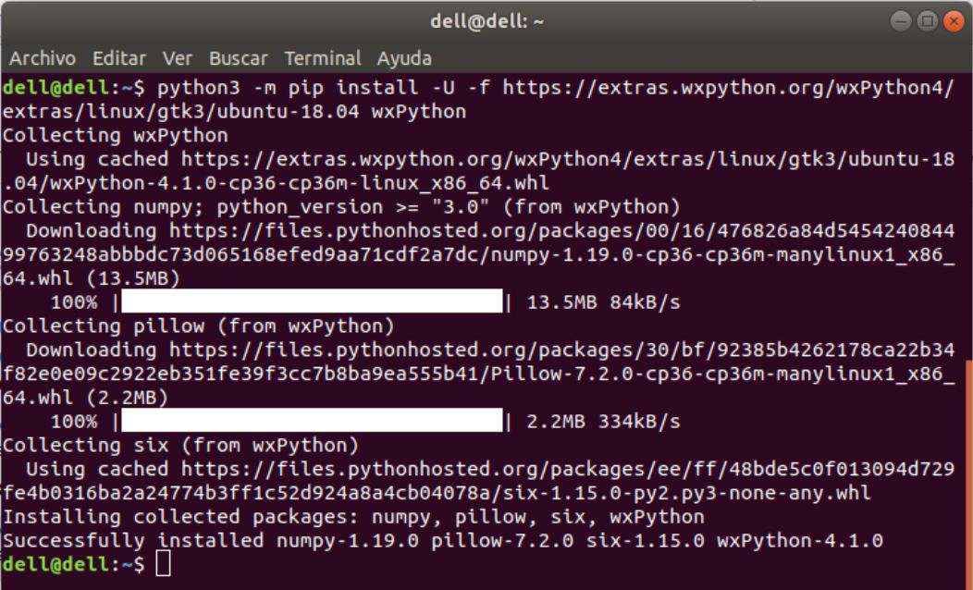

*Image 18 - Installation of wxPython with the previous command.*

1. Install matplotlib 2.2.3 or upper (Image 19):
   1. python3 -m pip install --user -U matplotlib

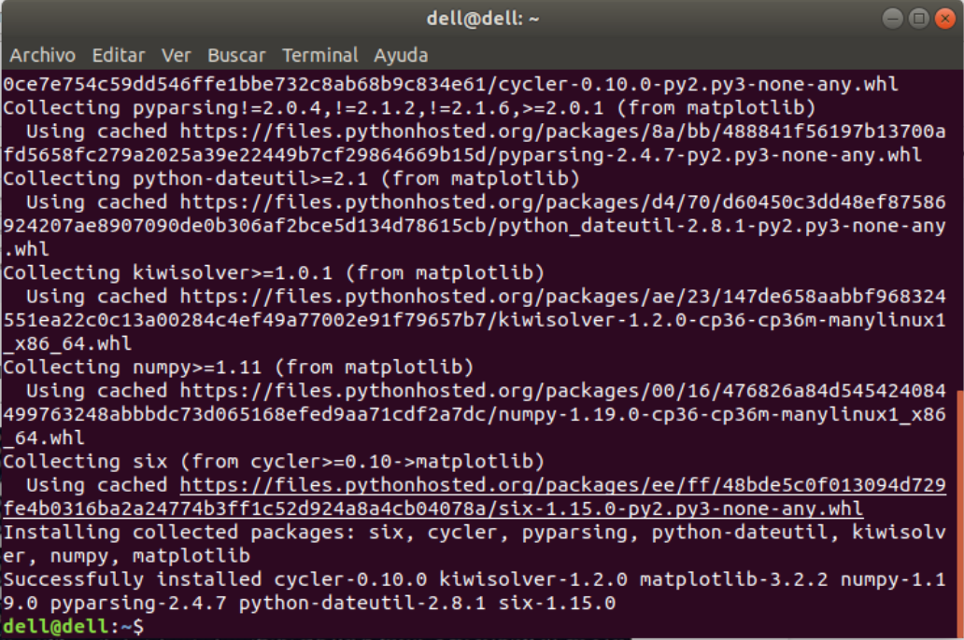

*Image 19 - Last part of the installation of matplotlib with the previous command.*

1. Install pandas (Image 20):
   1. python3 -m pip install --user -U pandas

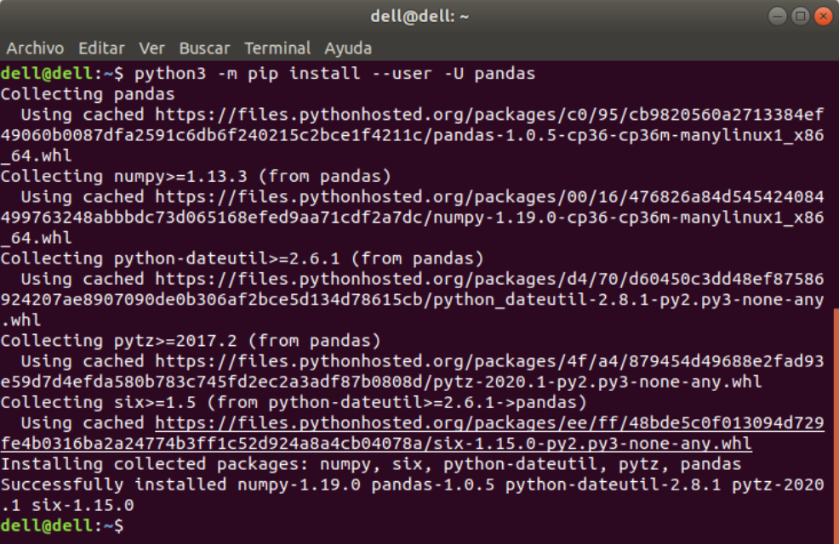

*Image 20 - Installation of pandas with the previous command.*

1. Install numpy (Image 21):
   1. python3 -m pip install --user -U numpy

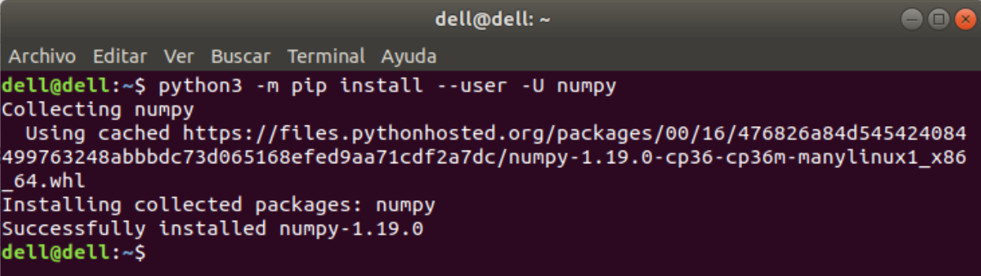

*Image 21 - Installation of numpy with the previous command.*

1. Install pygame:
   1. If you have ubuntu 20.04 you have to install pygame with sudo apt, if you have a previous version of ubuntu you can use pip to install pygame.
      1. For ubuntu 20.04:
         1. sudo apt-get install python3-pygame
      2. For previous versions (Image 22):
         1. python3 -m pip install --user -U pygame

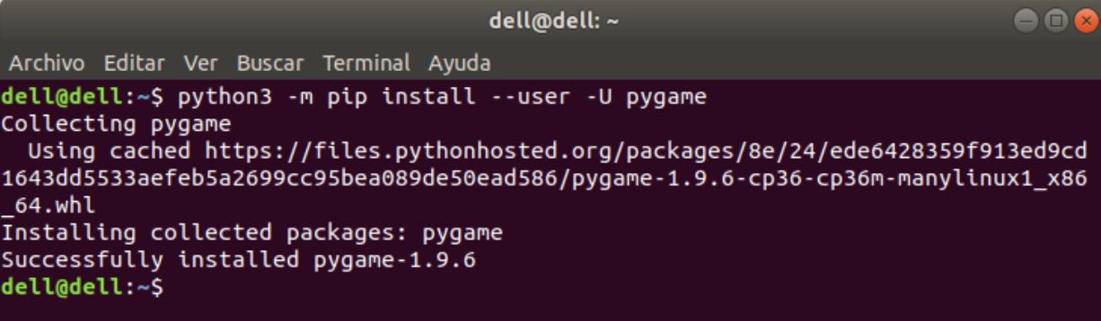

*Image 22 - Installation of pygame with the previous command.*

1. Install oct2py (Image 23):
   1. python3 -m pip install --user -U oct2py

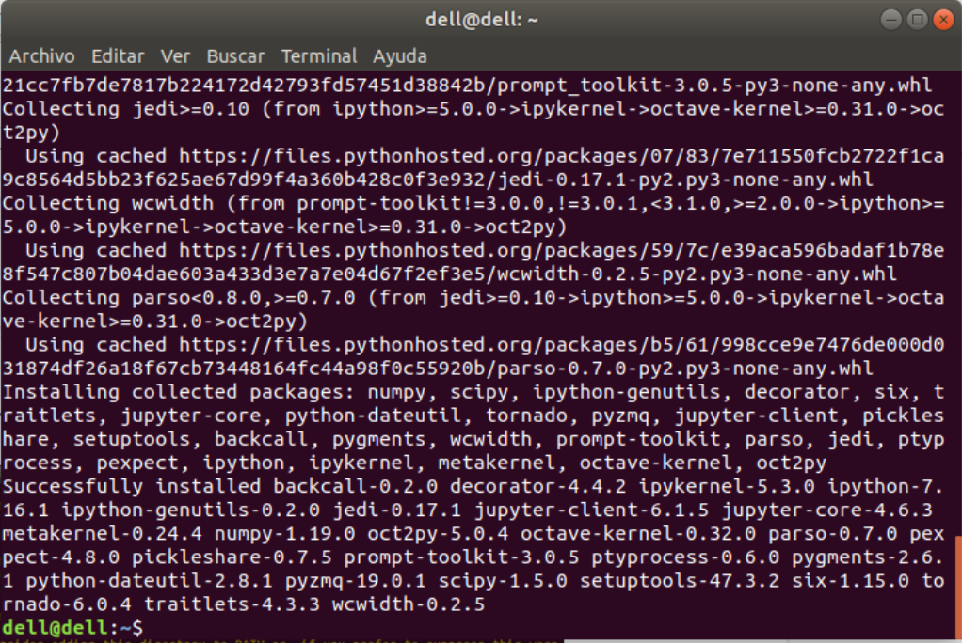

*Image 23 - Last part of the oct2py installation process, done with the previous command.*

**NOTE: if any of the last libraries (from 2 to 7) is missing, the soft does not run. The installation can take several minutes.**

1. Try that ‘oct2py’ was installed correctly with python on the terminal following the next steps (Image 24):
   1. Open python on the terminal with the command:
      1. python3
   2. Import ‘octave’ from ‘oct2py’ library with the command:
      1. from oct2py import octave
   3. If ‘octave’ is imported without problems (Image 25), type ‘exit()’ and jump to ‘Run the software’ section of this manual. On the other hand, if an error appear indicating a ‘SyntaxError’ (see Image 24) on the ‘../tornado/ioloop.py’ file you must follow the next steps to fix it.

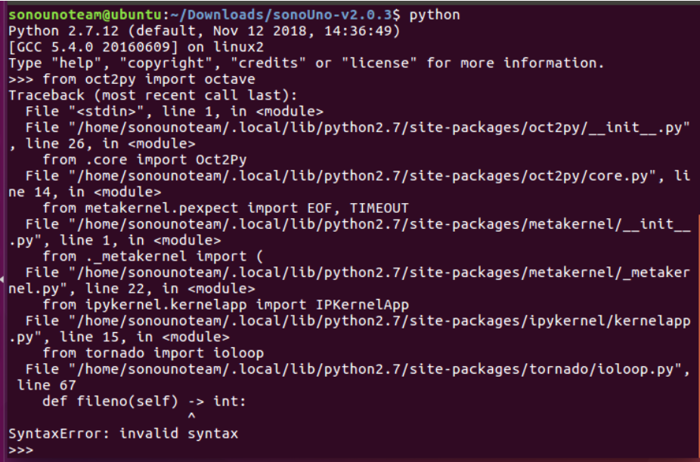

*Image 24 - Shows the library import command and the 'SyntaxError'.*

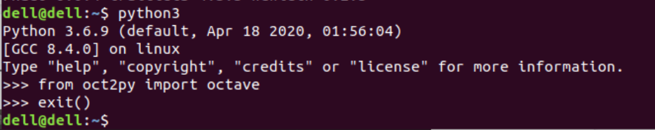

*Image 25 - Shows the library importation command without errors.*

1. To solve the problem with the oct2py library, you must uninstall tornado with the next command (Image 26):
   1. python3 -m pip uninstall tornado

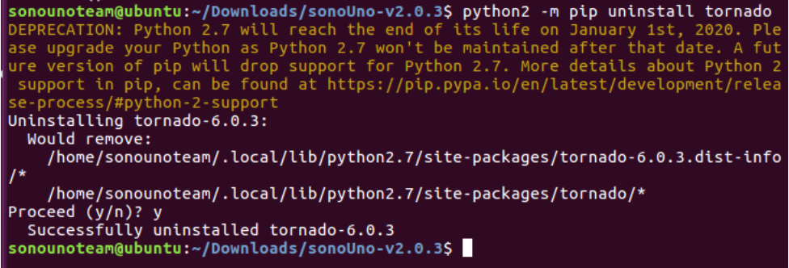

*Image 26 - Uninstallation of tornado with the previous command.*

1. Now you must install a previous version of tornado, in this case the version 5.1.1 works fine (Image 27).
   1. python3 -m pip install --user -U tornado==5.1.1

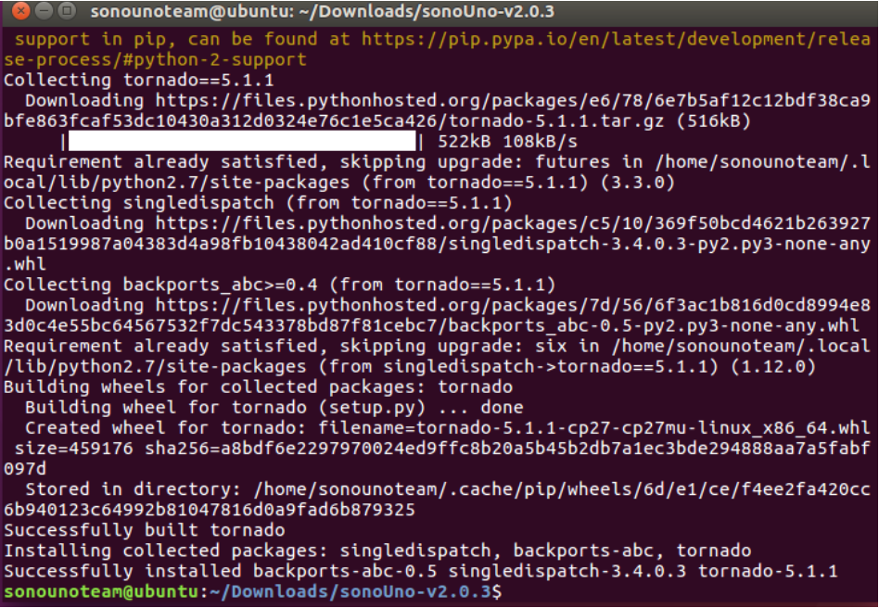

*Image 27 - Last part of the tornado installation process, done with the previous command.*

1. Finally, we test to import octave from the oct2py library:
   1. Open python on the terminal with the command:
      1. python3
   2. Import ‘octave’ from ‘oct2py’ library with the command:
      1. from oct2py import octave

**NOTE:** if a new error appears contact the development team, if not (see Image 25) continue with the section ‘Run the software’:

### 2.1.5. Possible errors

1. Problems the first time using pip, error ‘Command "python setup.py egg_info" failed with error code 1 in /tmp/pip-build-EtyARr/numpy/’ (see Image 28). Possible solution, update pip with the next command:
   1. sudo python3 -m pip install --upgrade pip

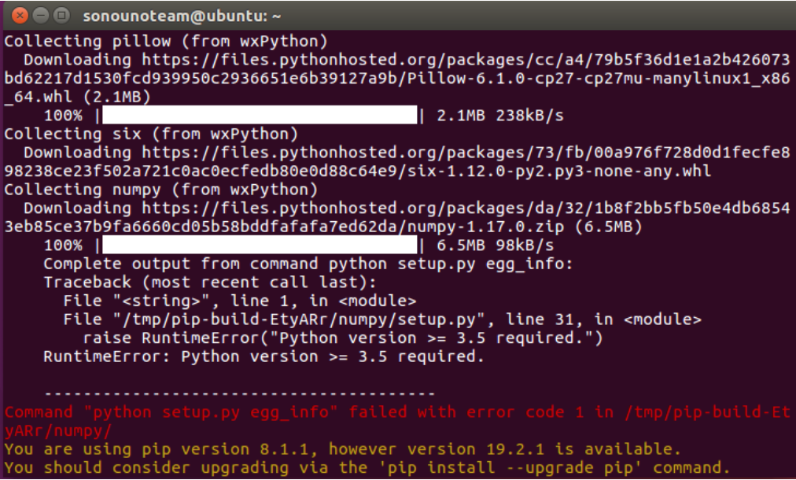

*Image 28 - Possible error the first time using pip on Ubuntu.*

### 2.1.6. Run the software

1. Unzip the file, if it is compressed. If you want to clone from github use the next line:
   1. git clone https://github.com/sonoUnoTeam/sonoUno.git
2. Open a terminal and go to the software folder. Probably you have more than one folder before you can run SonoUno. To check in which folder is sonoUno, use the command “ls” (Image 29). The sonoUno must be among the files and the manual in the folder.

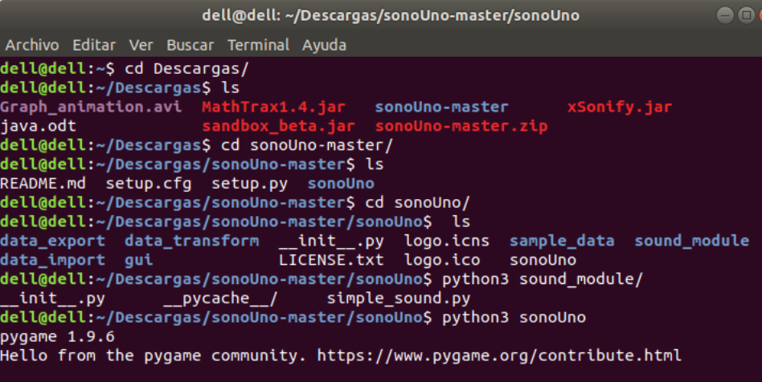

*Image 29 - Aspect of the sonoUno folder on the command window.*

1. Once you are sure that you are at the right folder, make:
   1. python3 sonoUno

**NOTE:** if you have the error “ImportError: libSDL-1.2.so.0: cannot open shared object file: No such file or directory” (Image 30); run “sudo apt-get install libsdl-ttf2.0-0”. If don’t solve the problem, contact the development team.

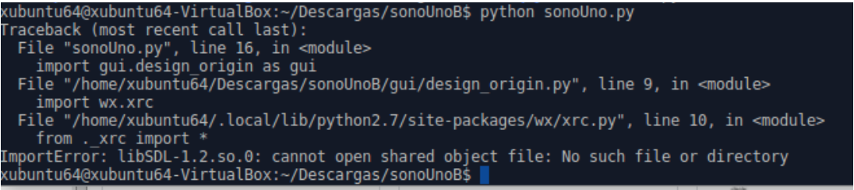

*Image 30 - libSDL possible error when you try to run the software the first time on Ubuntu.*

1. A window must be open (Image 31), if that is the case, the soft is ready to be used.

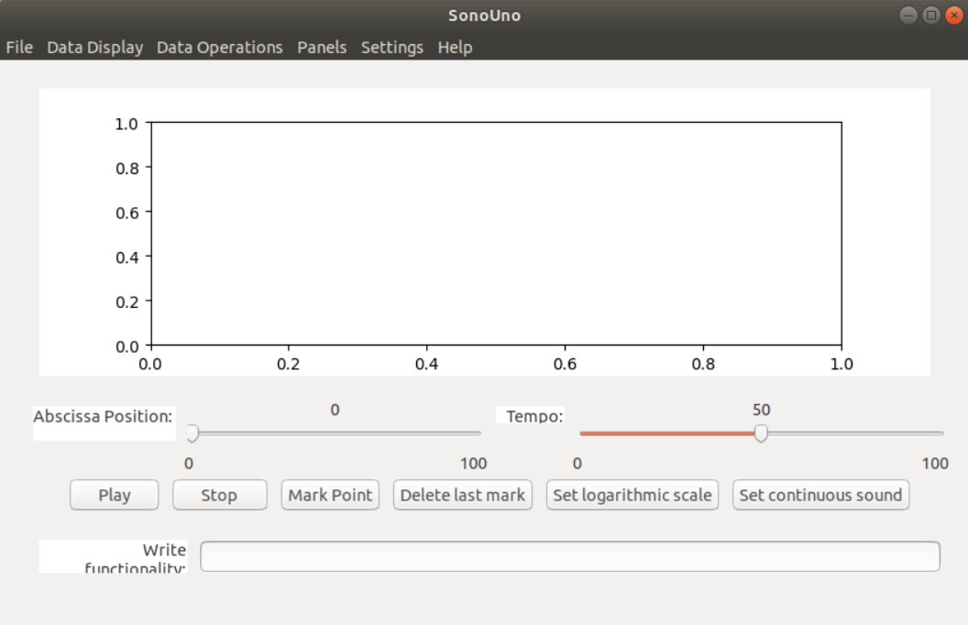

*Image 31 - SonoUno main window on Ubuntu.*

# 3. Import a file to the software

Once the software is installed, and you can open it, you are ready to try your first dataset. The initial window of the software only shows the plot and the reproduction options of the data (Image 31), the other functionalities are hide and were shown in the user manual. This design was based on a user cases study and ISO standards.

In order to probe the SonoUno, you have to import a data file. If you don’t have a data file, the installer provides a folder named “data” with simple functions on the installation directory or you can download this folder from github.

The first step to open a data file, is to select the item Open on the menu File. This action shows a new window of the file system of the computer, where you can choose the data file. Once you have the data file selected, press the button “Open” (Image 32).

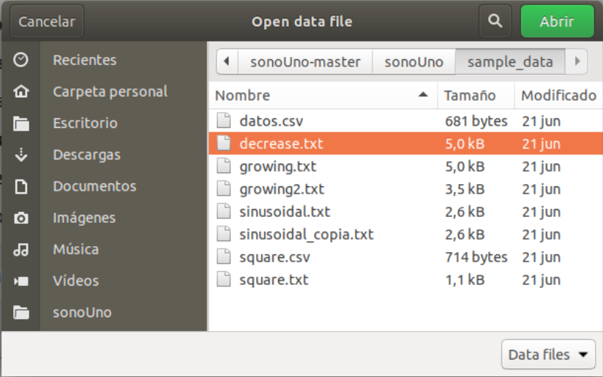

*Image 32 - New window of the file system of the computer.*

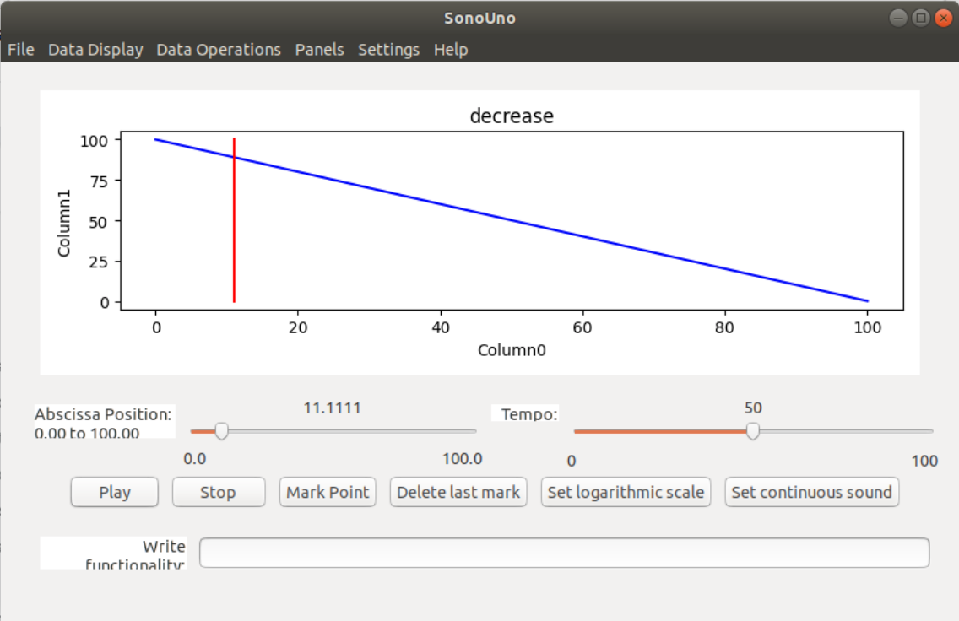

*Image 33 - Reproduction of the data file after press the button Play.*

After open the data file, the SonoUno show the plot and is ready to reproduce the pitch variation in Piano. In order to reproduce the sound, you have to press the button Play (Image 33). If the software installation is correct, you must listen a pitch variation on Piano and see a red vertical bar moving through the data, this bar indicate the position of the data that is been sonificated.

If the software doesn’t produce sound, check the speakers or headphones on your computer. If the problems continue or you have another problem, inform this to the developer team.